**Wireshark TCP**

1. **What is the IP address and TCP port number used by the client computer (source) that is transferring the file to gaia.cs.umass.edu? To answer this question, it’s probably easiest to select an HTTP message and explore the details of the TCP packet used to carry this HTTP message, using the “details of the selected packet header window”**

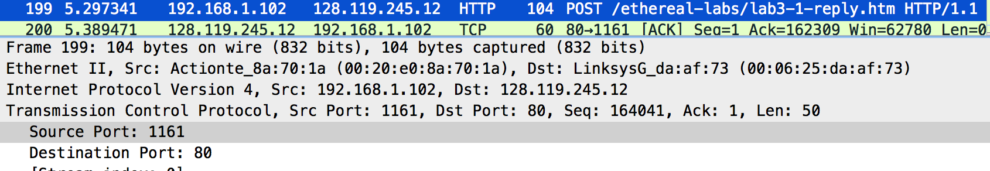

Source IP: 192.168.1.102

Source Port: 1161

1. **What is the IP address of gaia.cs.umass.edu? On what port number is it sending and receiving TCP segments for this connection?**



Destination IP: 128.119.245.12

Destination Port: 80

1. **What is the IP address and TCP port number used by your client computer (source) to transfer the file to gaia.cs.umass.edu?**

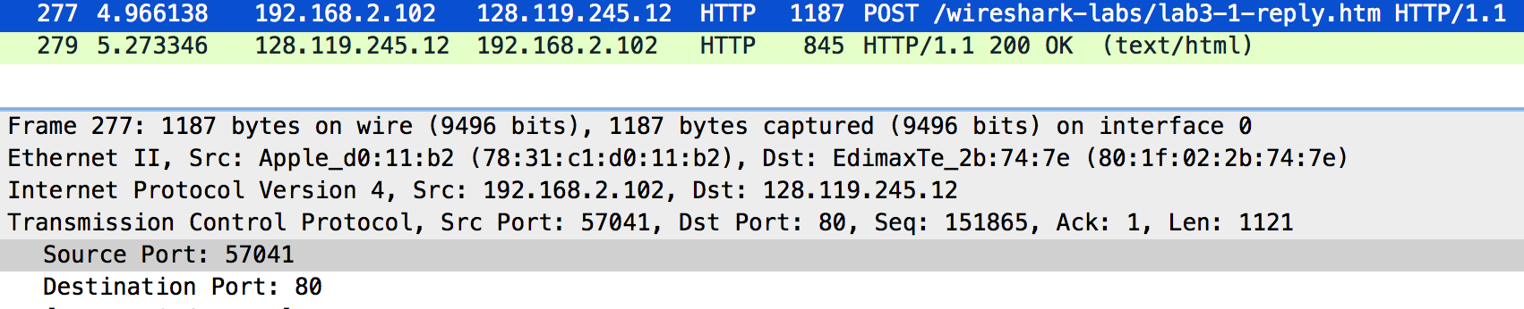

Source IP: 192.168.2.102

Source Port: 57041

1. **What is the sequence number of the TCP SYN segment that is used to initiate the TCP connection between the client computer and gaia.cs.umass.edu? What is it in the segment that identifies the segment as a SYN segment?**

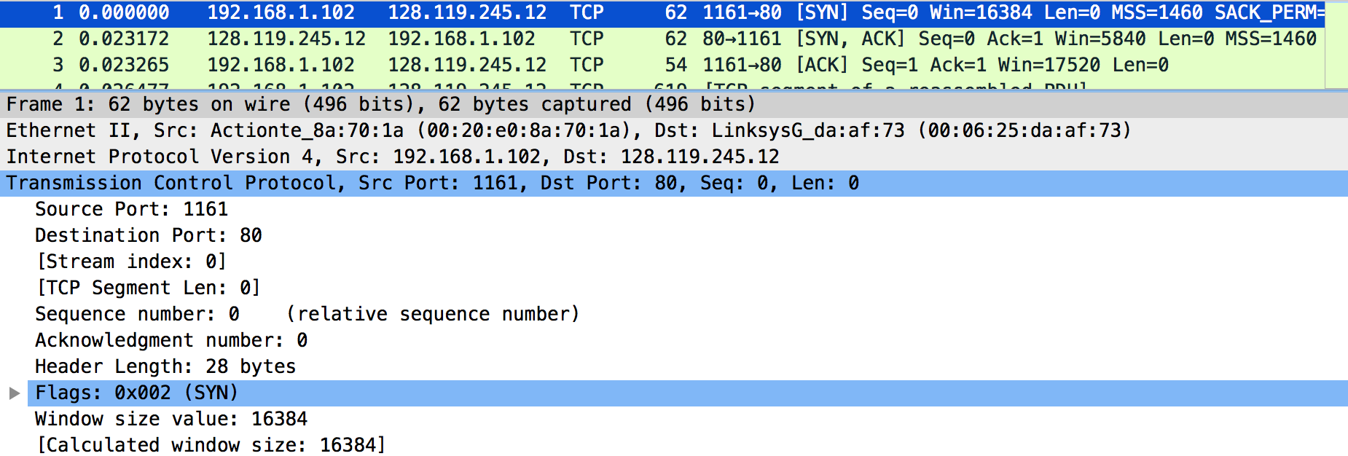

Sequence number of the initial TCP SYN is 0.

The Flags value helps us to identify that this is a SYN segment.

1. **What is the sequence number of the SYNACK segment sent by gaia.cs.umass.edu to the client computer in reply to the SYN? What is the value of the Acknowledgement field in the SYNACK segment? How did gaia.cs.umass.edu determine that value? What is it in the segment that identifies the segment as a SYNACK segment?**

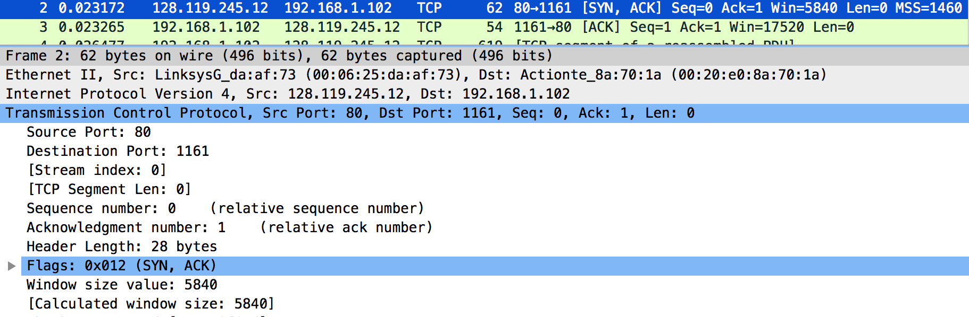

Sequence number of the TCP SYNACK is 0.

The value of the Acknowledgement number is 1 => This value is obtained by adding 1 to the sequence number of the previous segment (in this case is the initial SYN segment). From question [4], we know that sequence number of initial SYN is 0.

The Flags value helps us to identify that this is a SYNACK segment.

1. **What is the sequence number of the TCP segment containing the HTTP POST command? Note that in order to find the POST command, you’ll need to dig into the packet content field at the bottom of the Wireshark window, looking for a segment with a “POST” within its DATA field.**

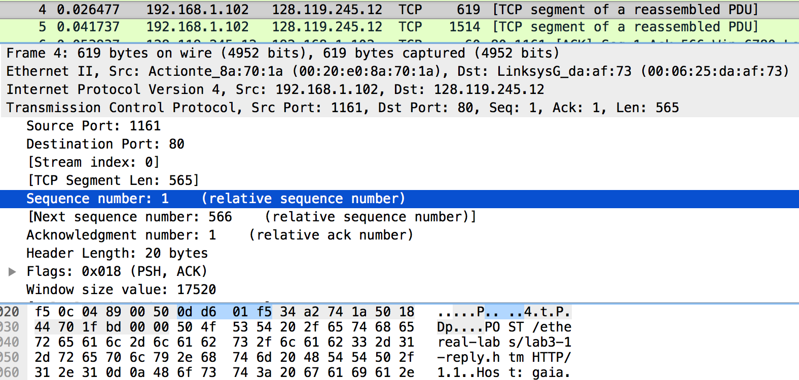

The sequence number of the TCP segment containing the HTTP POST Command is: 1

1. **Consider the TCP segment containing the HTTP POST as the first segment in the TCP connection. What are the sequence numbers of the first six segments in the TCP connection (including the segment containing the HTTP POST)? At what time was each segment sent? When was the ACK for each segment received? Given the difference between when each TCP segment was sent, and when its acknowledgement was received, what is the RTT value for each of the six segments? What is the EstimatedRTT value after the receipt of each ACK? Assume that the value of the EstimatedRTT is equal to the measured RTT for the first segment, and then is computed using the EstimatedRTT equation on page 242 for all subsequent segments**

|  |  |  |  |  |  |
| --- | --- | --- | --- | --- | --- |
| **Seg.** | **Seq. num** | **Sent time** | **ACK time** | **RTT** | **EstimatedRTT** |
| 1 | 1 | 0.026477 | 0.053937 | 0.027460 | 0.027460 |
| 2 | 566 | 0.041737 | 0.077294 | 0.035557 | 0.028472 |
| 3 | 2066 | 0.054026 | 0.124085 | 0.070059 | 0.033670 |
| 4 | 3486 | 0.054690 | 0.169118 | 0.114428 | 0.043765 |
| 5 | 4946 | 0.077450 | 0.217299 | 0.139849 | 0.055776 |
| 6 | 6406 | 0.078157 | 0.267802 | 0.189645 | 0.072509 |

(Time is calculated in seconds)

1. **What is the length of each of the first six TCP segments?**

|  |  |
| --- | --- |
| Segment | Length |
| 1 | 619 |
| 2 | 1514 |
| 3 | 1514 |
| 4 | 1514 |
| 5 | 1514 |
| 6 | 1514 |

1. **What is the minimum amount of available buffer space advertised at the received for the entire trace? Does the lack of receiver buffer space ever throttle the sender?**

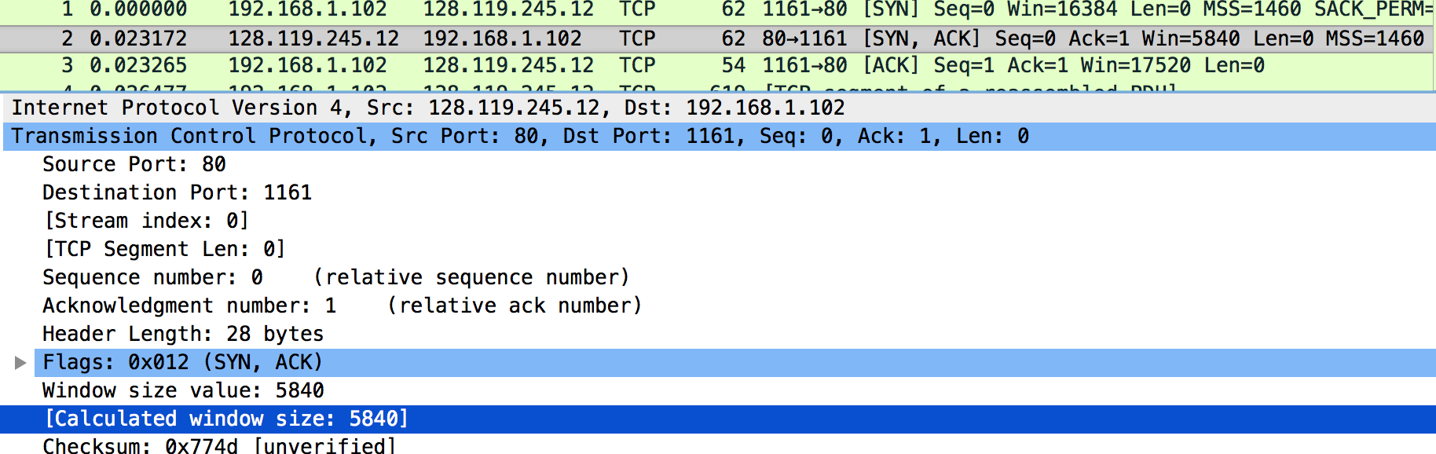

After examine all of the SYN and SYNACK packet, the minimum amount of available buffer space (Calculated Window Size) is 5840. The lack of receiver buffer space does not ever throttle the sender, because there is no sum of consecutive segments (between 2 ACK) exceeds the Calculated Window Size at the moment (Note that the CW Size increases up to 62780 bytes)

1. **Are there any retransmitted segments in the trace file? What did you check for (in the trace) in order to answer this question?**

I did not see two identical packets has the same sequence number, thus there is no retransmitted segments in the trace file.

1. **How much data does the receiver typically acknowledge in an ACK? Can you identify cases where the receiver is ACKing every other received segment (see Table 3.2 on page 250 in the text).**

The receiver typically acknowledges in an ACK for each 1460 bytes.

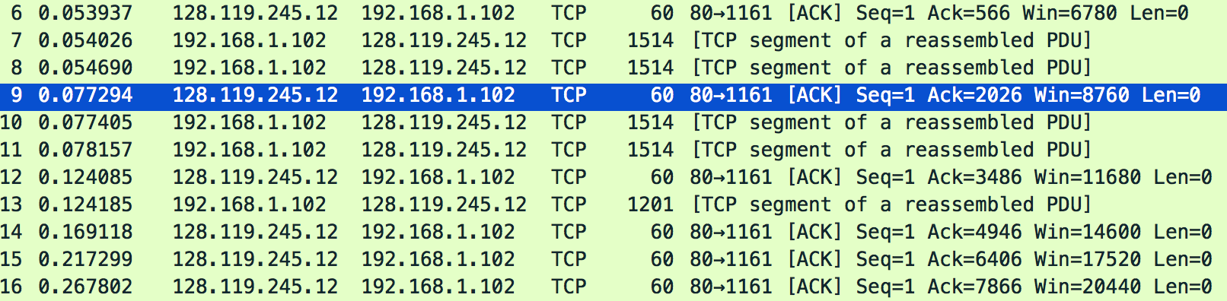

However, there is a case that the receiver acknowledges 2 consecutive segments via one ACK packet sent back to the sender.

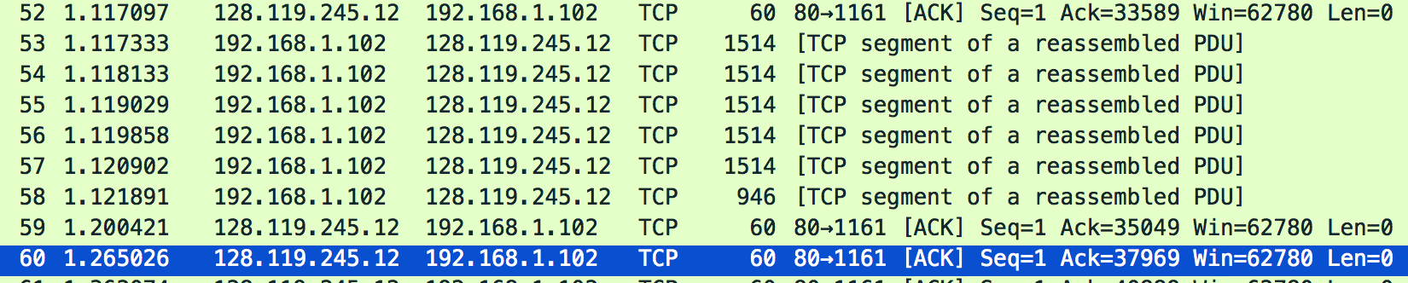

37969 – 35049 = 2920 = 2 * 1460 = 2 * [Maximum Size Segment]

1. **What is the throughput (bytes transferred per unit time) for the TCP connection? Explain how you calculated this value.**

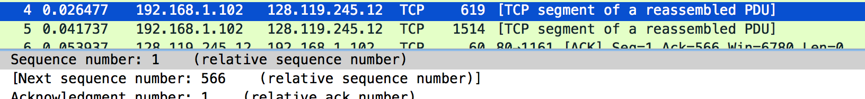

Sequence number of the first packet being sent is 1

../../../../../../../../Desktop/Screen%20Shot%202016-12-09%2

The Acknowledgement number of the last ACK from receiver is 164091

**../../../../../../../../Desktop/Screen%20Shot%202016-12-09%2**

**../../../../../../../../Desktop/Screen%20Shot%202016-12-09%2**

Time from the first packet being sent till the last ACK from the receiver is 5.429353 (seconds)

* Throughput = 164091 / 5.429353 ~ 30222.94 KB/s = 241783.5053 Kbit/s

1. 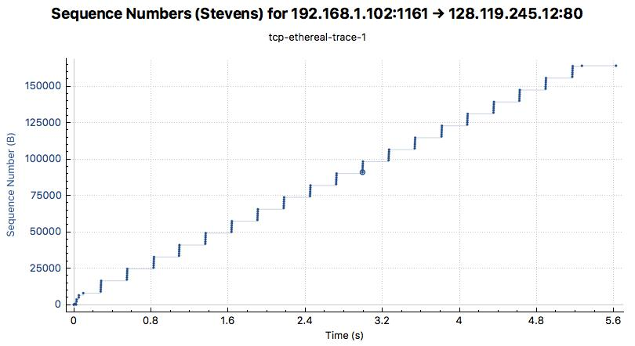**Use the Time-Sequence-Graph(Stevens) plotting tool to view the sequence number versus time plot of segments being sent from the client to the gaia.cs.umass.edu server. Can you identify where TCP’s slowstart phase begins and ends, and where congestion avoidance takes over? Comment on ways in which the measured data differs from the idealized behavior of TCP that we’ve studied in the text.**

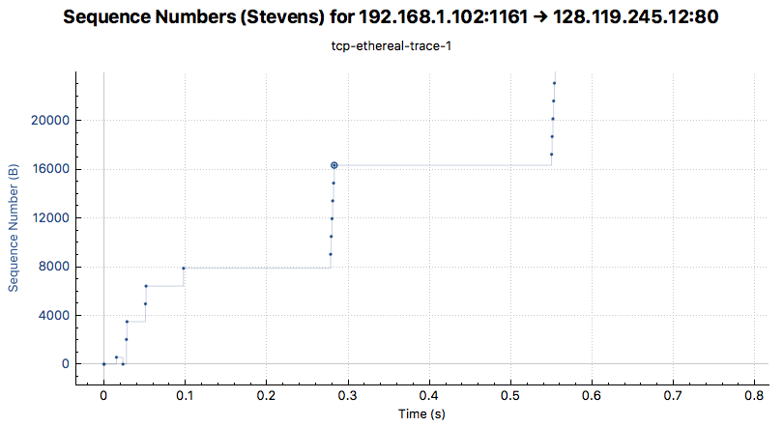 Zoom to the bottom left corner:

The Slow-start phase begins from second 0 to second 0.1

The Congestion-Avoidance phase takes over after then.

According to the idealized behavior from the book, there should be a linear increase of the congestion window (infer via the number of packets in a batch, which is a batch of 6 packets). However, we only see that the TCP transmit the packets in batches of 6 packets. When I select a packet about second 0.3, i.e, packet #18, I see that the immediate previous ACK packet (from the receiver) shows that the receiver’s Calculated Window Size is 23360, which can contain much more than only 6 packets, each with size of 1460 bytes.

1. **Answer each of two questions above for the trace that you have gathered when you transferred a file from your computer to gaia.cs.umass.edu**

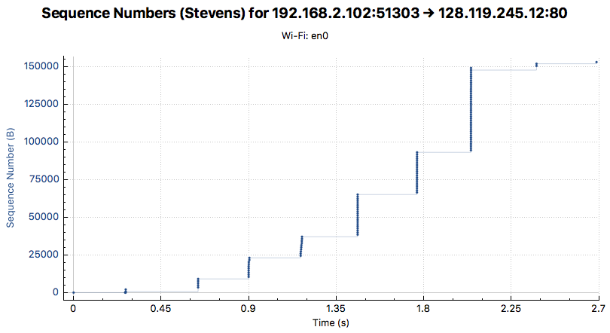

The Slow-start phase begins from second 0 to second 2.7 (during the entire connection)

There is no Congestion-Avoidance phase.

From second range [0.9, 1.2] and [1.5, 1.8], they do not double the batch of packet as usual. This is due to some retransmission data packet (I have checked the packet list).